https://machinelearningmastery.com/roc-curves-and-precision-recall-curves-for-classification-in-python/

Specifically,:

* ROC Curves summarize the trade-off between the true positive rate and false positive rate for a predictive model using different probability thresholds.
* Precision-Recall curves summarize the trade-off between the true positive rate and the positive predictive value for a predictive model using different probability thresholds.
* ROC curves are appropriate when the observations are balanced between each class, whereas precision-recall curves are appropriate for imbalanced datasets.

1. Predicting Probabilities
2. What Are ROC Curves?
3. ROC Curves and AUC in Python
4. What Are Precision-Recall Curves?
5. Precision-Recall Curves and AUC in Python
6. When to Use ROC vs. Precision-Recall Curves?

**Predicting Probabilities**

In a classification problem, we may decide to predict the class values directly.

Alternately, it can be more flexible to predict the probabilities for each class instead. The reason for this is to provide the capability to choose and even calibrate the threshold for how to interpret the predicted probabilities.

For example, a default might be to use a threshold of 0.5, meaning that a probability in [0.0, 0.49] is a negative outcome (0) and a probability in [0.5, 1.0] is a positive outcome (1).

This threshold can be adjusted to tune the behavior of the model for a specific problem. An example would be to reduce more of one or another type of error.

When making a prediction for a binary or two-class classification problem, there are two types of errors that we could make.

* **False Positive**. Predict an event when there was no event.
* **False Negative**. Predict no event when in fact there was an event.

By predicting probabilities and calibrating a threshold, a balance of these two concerns can be chosen by the operator of the model.

For example, in a smog prediction system, we may be far more concerned with having low false negatives than low false positives. A false negative would mean not warning about a smog day when in fact it is a high smog day, leading to health issues in the public that are unable to take precautions. A false positive means the public would take precautionary measures when they didn’t need to.

A common way to compare models that predict probabilities for two-class problems is to use a ROC curve.

**What Are ROC Curves?**

A useful tool when predicting the probability of a binary outcome is the [Receiver Operating Characteristic curve](https://en.wikipedia.org/wiki/Receiver_operating_characteristic), or ROC curve.

It is a plot of the false positive rate (x-axis) versus the true positive rate (y-axis) for a number of different candidate threshold values between 0.0 and 1.0. Put another way, it plots the false alarm rate versus the hit rate.

The true positive rate is calculated as the number of true positives divided by the sum of the number of true positives and the number of false negatives. It describes how good the model is at predicting the positive class when the actual outcome is positive.



|  |  |
| --- | --- |
| 1 | True Positive Rate = True Positives / (True Positives + False Negatives) |

The true positive rate is also referred to as sensitivity.



|  |  |
| --- | --- |
| 1 | Sensitivity = True Positives / (True Positives + False Negatives) |

The false positive rate is calculated as the number of false positives divided by the sum of the number of false positives and the number of true negatives.

It is also called the false alarm rate as it summarizes how often a positive class is predicted when the actual outcome is negative.



|  |  |
| --- | --- |
| 1 | False Positive Rate = False Positives / (False Positives + True Negatives) |

The false positive rate is also referred to as the inverted specificity where specificity is the total number of true negatives divided by the sum of the number of true negatives and false positives.



|  |  |
| --- | --- |
| 1 | Specificity = True Negatives / (True Negatives + False Positives) |

Where:



|  |  |
| --- | --- |
| 1 | False Positive Rate = 1 - Specificity |

The ROC curve is a useful tool for a few reasons:

* The curves of different models can be compared directly in general or for different thresholds.
* The area under the curve (AUC) can be used as a summary of the model skill.

The shape of the curve contains a lot of information, including what we might care about most for a problem, the expected false positive rate, and the false negative rate.

To make this clear:

* Smaller values on the x-axis of the plot indicate lower false positives and higher true negatives.
* Larger values on the y-axis of the plot indicate higher true positives and lower false negatives.

If you are confused, remember, when we predict a binary outcome, it is either a correct prediction (true positive) or not (false positive). There is a tension between these options, the same with true negative and false negative.

A skilful model will assign a higher probability to a randomly chosen real positive occurrence than a negative occurrence on average. This is what we mean when we say that the model has skill. Generally, skilful models are represented by curves that bow up to the top left of the plot.

A model with no skill is represented at the point [0.5, 0.5]. A model with no skill at each threshold is represented by a diagonal line from the bottom left of the plot to the top right and has an AUC of 0.5.

A model with perfect skill is represented at a point [0.0 ,1.0]. A model with perfect skill is represented by a line that travels from the bottom left of the plot to the top left and then across the top to the top right.

An operator may plot the ROC curve for the final model and choose a threshold that gives a desirable balance between the false positives and false negatives.

**ROC Curves and AUC in Python**

We can plot a ROC curve for a model in Python using the *roc_curve()* scikit-learn function.

The function takes both the true outcomes (0,1) from the test set and the predicted probabilities for the 1 class. The function returns the false positive rates for each threshold, true positive rates for each threshold and thresholds.



|  |  |
| --- | --- |
| 1  2 | # calculate roc curve  fpr, tpr, thresholds = roc_curve(y, probs) |

The AUC for the ROC can be calculated using the *roc_auc_score()* function.

Like the *roc_curve()* function, the AUC function takes both the true outcomes (0,1) from the test set and the predicted probabilities for the 1 class. It returns the AUC score between 0.0 and 1.0 for no skill and perfect skill respectively.



|  |  |
| --- | --- |
| 1  2  3 | # calculate AUC  auc = roc_auc_score(y, probs)  print('AUC: %.3f' % auc) |

A complete example of calculating the ROC curve and AUC for a logistic regression model on a small test problem is listed below.



|  |  |
| --- | --- |
| 1  2  3  4  5  6  7  8  9  10  11  12  13  14  15  16  17  18  19  20  21  22  23  24  25  26  27  28  29 | # roc curve and auc  from sklearn.datasets import make_classification  from sklearn.neighbors import KNeighborsClassifier  from sklearn.model_selection import train_test_split  from sklearn.metrics import roc_curve  from sklearn.metrics import roc_auc_score  from matplotlib import pyplot  # generate 2 class dataset  X, y = make_classification(n_samples=1000, n_classes=2, weights=[1,1], random_state=1)  # split into train/test sets  trainX, testX, trainy, testy = train_test_split(X, y, test_size=0.5, random_state=2)  # fit a model  model = KNeighborsClassifier(n_neighbors=3)  model.fit(trainX, trainy)  # predict probabilities  probs = model.predict_proba(testX)  # keep probabilities for the positive outcome only  probs = probs[:, 1]  # calculate AUC  auc = roc_auc_score(testy, probs)  print('AUC: %.3f' % auc)  # calculate roc curve  fpr, tpr, thresholds = roc_curve(testy, probs)  # plot no skill  pyplot.plot([0, 1], [0, 1], linestyle='--')  # plot the roc curve for the model  pyplot.plot(fpr, tpr, marker='.')  # show the plot  pyplot.show() |

Running the example prints the area under the ROC curve.



|  |  |
| --- | --- |
| 1 | AUC: 0.895 |

A plot of the ROC curve for the model is also created showing that the model has skill.

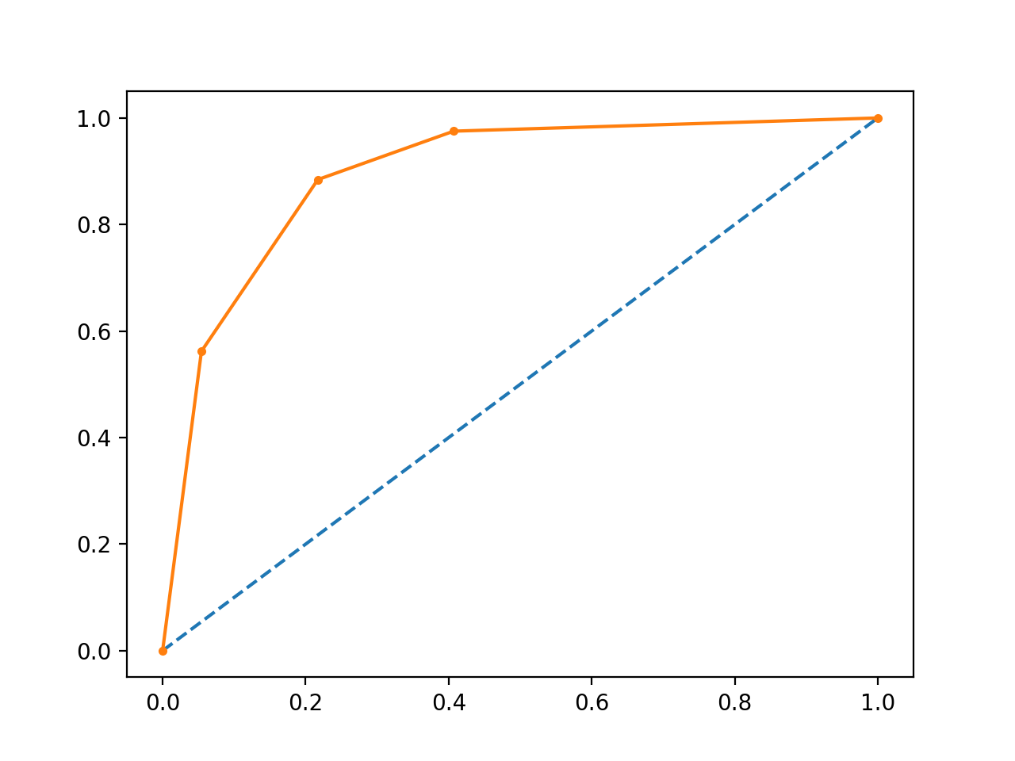

Line Plot of ROC Curve

**What Are Precision-Recall Curves?**

There are many ways to evaluate the skill of a prediction model.

An approach in the related field of [information retrieval](https://en.wikipedia.org/wiki/Information_retrieval) (finding documents based on queries) measures [precision and recall](https://en.wikipedia.org/wiki/Precision_and_recall).

These measures are also useful in applied machine learning for evaluating binary classification models.

Precision is a ratio of the number of true positives divided by the sum of the true positives and false positives. It describes how good a model is at predicting the positive class. Precision is referred to as the positive predictive value.



|  |  |
| --- | --- |
| 1 | Positive Predictive Power = True Positives / (True Positives + False Positives) |

or



|  |  |
| --- | --- |
| 1 | Precision = True Positives / (True Positives + False Positives) |

Recall is calculated as the ratio of the number of true positives divided by the sum of the true positives and the false negatives. Recall is the same as sensitivity.



|  |  |
| --- | --- |
| 1 | Recall = True Positives / (True Positives + False Negatives) |

or



|  |  |
| --- | --- |
| 1 | Sensitivity = True Positives / (True Positives + False Negatives) |



|  |  |
| --- | --- |
| 1 | Recall == Sensitivity |

Reviewing both precision and recall is useful in cases where there is an imbalance in the observations between the two classes. Specifically, there are many examples of no event (class 0) and only a few examples of an event (class 1).

The reason for this is that typically the large number of class 0 examples means we are less interested in the skill of the model at predicting class 0 correctly, e.g. high true negatives.

Key to the calculation of precision and recall is that the calculations do not make use of the true negatives. It is only concerned with the correct prediction of the minority class, class 1.

A precision-recall curve is a plot of the precision (y-axis) and the recall (x-axis) for different thresholds, much like the ROC curve.

The no-skill line is defined by the total number of positive cases divide by the total number of positive and negative cases. For a dataset with an equal number of positive and negative cases, this is a straight line at 0.5. Points above this line show skill.

A model with perfect skill is depicted as a point at [1.0,1.0]. A skilful model is represented by a curve that bows towards [1.0,1.0] above the flat line of no skill.

There are also composite scores that attempt to summarize the precision and recall; three examples include:

* **F score** or [F1 score](https://en.wikipedia.org/wiki/F1_score): that calculates the harmonic mean of the precision and recall (harmonic mean because the precision and recall are ratios).
* **Average precision**: that summarizes the weighted increase in precision with each change in recall for the thresholds in the precision-recall curve.
* **Area Under Curve**: like the AUC, summarizes the integral or an approximation of the area under the precision-recall curve.

In terms of model selection, F1 summarizes model skill for a specific probability threshold, whereas average precision and area under curve summarize the skill of a model across thresholds, like ROC AUC.

This makes precision-recall and a plot of precision vs. recall and summary measures useful tools for binary classification problems that have an imbalance in the observations for each class.

**Precision-Recall Curves in Python**

Precision and recall can be calculated in scikit-learn via the *precision_score()* and *recall_score()* functions.

The precision and recall can be calculated for thresholds using the *precision_recall_curve()* function that takes the true output values and the probabilities for the positive class as output and returns the precision, recall and threshold values.



|  |  |
| --- | --- |
| 1  2 | # calculate precision-recall curve  precision, recall, thresholds = precision_recall_curve(testy, probs) |

The F1 score can be calculated by calling the *f1_score()* function that takes the true class values and the predicted class values as arguments.



|  |  |
| --- | --- |
| 1  2 | # calculate F1 score  f1 = f1_score(testy, yhat) |

The area under the precision-recall curve can be approximated by calling the *auc()* function and passing it the recall and precision values calculated for each threshold.



|  |  |
| --- | --- |
| 1  2 | # calculate precision-recall AUC  auc = auc(recall, precision) |

Finally, the average precision can be calculated by calling the *average_precision_score()* function and passing it the true class values and the predicted class values.

The complete example is listed below.



|  |  |
| --- | --- |
| 1  2  3  4  5  6  7  8  9  10  11  12  13  14  15  16  17  18  19  20  21  22  23  24  25  26  27  28  29  30  31  32  33  34  35  36  37 | # precision-recall curve and f1  from sklearn.datasets import make_classification  from sklearn.neighbors import KNeighborsClassifier  from sklearn.model_selection import train_test_split  from sklearn.metrics import precision_recall_curve  from sklearn.metrics import f1_score  from sklearn.metrics import auc  from sklearn.metrics import average_precision_score  from matplotlib import pyplot  # generate 2 class dataset  X, y = make_classification(n_samples=1000, n_classes=2, weights=[1,1], random_state=1)  # split into train/test sets  trainX, testX, trainy, testy = train_test_split(X, y, test_size=0.5, random_state=2)  # fit a model  model = KNeighborsClassifier(n_neighbors=3)  model.fit(trainX, trainy)  # predict probabilities  probs = model.predict_proba(testX)  # keep probabilities for the positive outcome only  probs = probs[:, 1]  # predict class values  yhat = model.predict(testX)  # calculate precision-recall curve  precision, recall, thresholds = precision_recall_curve(testy, probs)  # calculate F1 score  f1 = f1_score(testy, yhat)  # calculate precision-recall AUC  auc = auc(recall, precision)  # calculate average precision score  ap = average_precision_score(testy, probs)  print('f1=%.3f auc=%.3f ap=%.3f' % (f1, auc, ap))  # plot no skill  pyplot.plot([0, 1], [0.5, 0.5], linestyle='--')  # plot the precision-recall curve for the model  pyplot.plot(recall, precision, marker='.')  # show the plot  pyplot.show() |

Running the example first prints the F1, area under curve (AUC) and average precision (AP) scores.



|  |  |
| --- | --- |
| 1 | f1=0.836 auc=0.892 ap=0.840 |

The precision-recall curve plot is then created showing the precision/recall for each threshold compared to a no skill model.

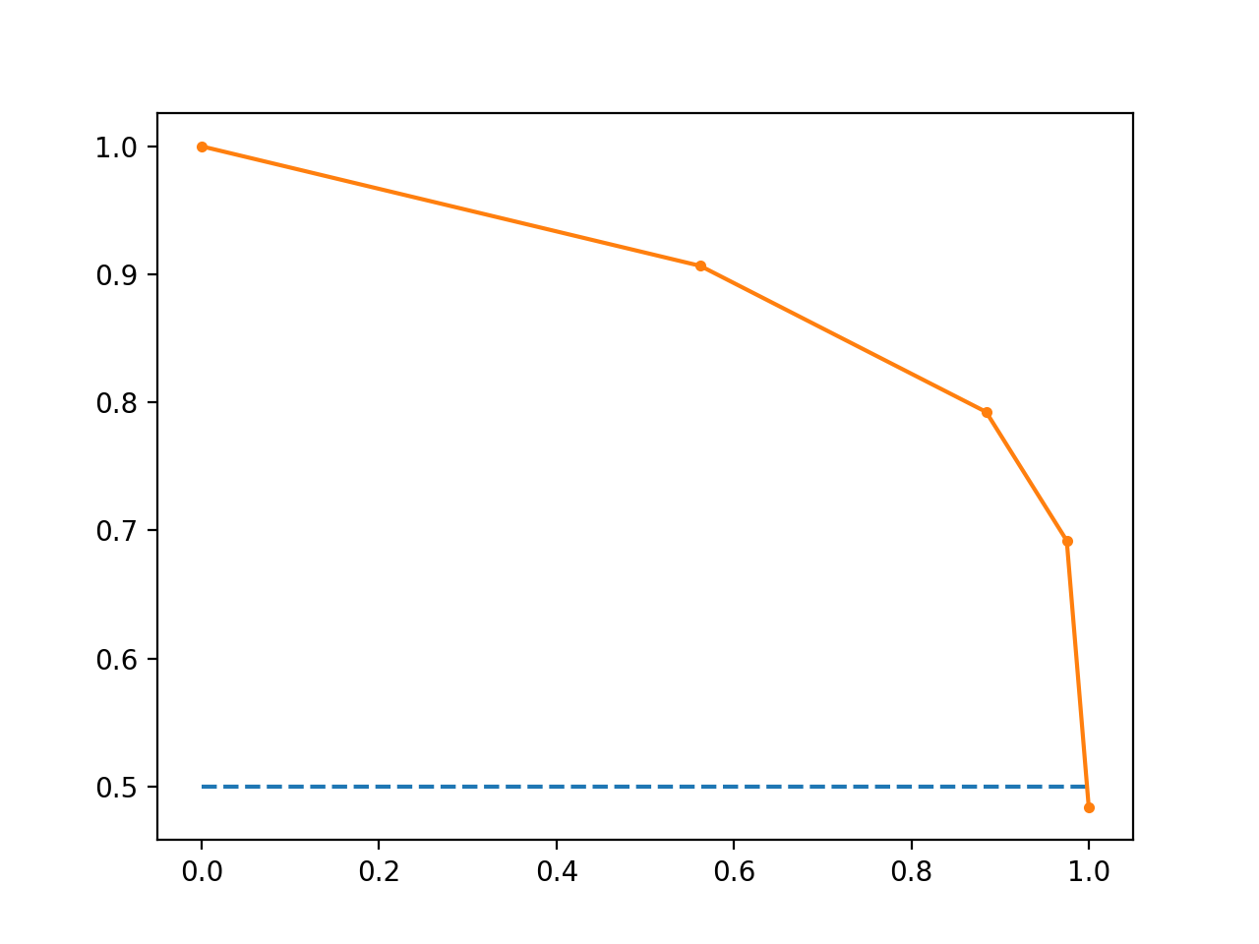

Line Plot of Precision-Recall Curve

**When to Use ROC vs. Precision-Recall Curves?**

Generally, the use of ROC curves and precision-recall curves are as follows:

* ROC curves should be used when there are roughly equal numbers of observations for each class.
* Precision-Recall curves should be used when there is a moderate to large class imbalance.

The reason for this recommendation is that ROC curves present an optimistic picture of the model on datasets with a class imbalance.

However, ROC curves can present an overly optimistic view of an algorithm’s performance if there is a large skew in the class distribution. […] Precision-Recall (PR) curves, often used in Information Retrieval , have been cited as an alternative to ROC curves for tasks with a large skew in the class distribution.

We can make this concrete with a short example.

Below is the same ROC Curve example with a modified problem where there is a 10:1 ratio of class=0 to class=1 observations.



|  |  |
| --- | --- |
| 1  2  3  4  5  6  7  8  9  10  11  12  13  14  15  16  17  18  19  20  21  22  23  24  25  26  27  28  29 | # roc curve and auc on imbalanced dataset  from sklearn.datasets import make_classification  from sklearn.neighbors import KNeighborsClassifier  from sklearn.model_selection import train_test_split  from sklearn.metrics import roc_curve  from sklearn.metrics import roc_auc_score  from matplotlib import pyplot  # generate 2 class dataset  X, y = make_classification(n_samples=1000, n_classes=2, weights=[0.9,0.09], random_state=1)  # split into train/test sets  trainX, testX, trainy, testy = train_test_split(X, y, test_size=0.5, random_state=2)  # fit a model  model = KNeighborsClassifier(n_neighbors=3)  model.fit(trainX, trainy)  # predict probabilities  probs = model.predict_proba(testX)  # keep probabilities for the positive outcome only  probs = probs[:, 1]  # calculate AUC  auc = roc_auc_score(testy, probs)  print('AUC: %.3f' % auc)  # calculate roc curve  fpr, tpr, thresholds = roc_curve(testy, probs)  # plot no skill  pyplot.plot([0, 1], [0, 1], linestyle='--')  # plot the precision-recall curve for the model  pyplot.plot(fpr, tpr, marker='.')  # show the plot  pyplot.show() |

Running the example suggests that the model has skill.



|  |  |
| --- | --- |
| 1 | AUC: 0.713 |

Indeed, it has skill, but much of that skill is measured as making correct true negative predictions and there are a lot of negative predictions to make.

A plot of the ROC Curve confirms the AUC interpretation of a skilful model for most probability thresholds.

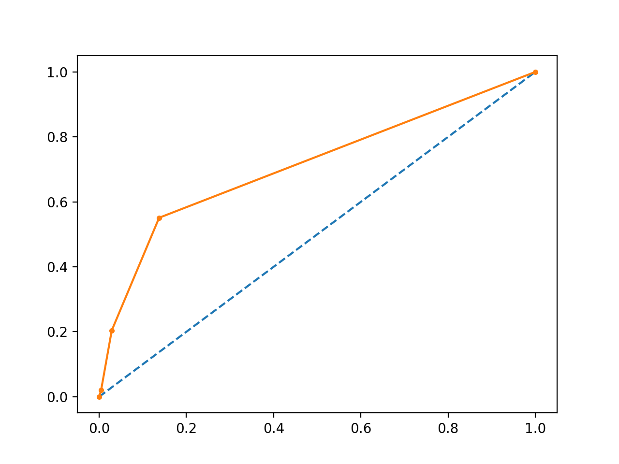

Line Plot of ROC Curve Imbalanced Dataset

We can also repeat the test of the same model on the same dataset and calculate a precision-recall curve and statistics instead.

The complete example is listed below.



|  |  |
| --- | --- |
| 1  2  3  4  5  6  7  8  9  10  11  12  13  14  15  16  17  18  19  20  21  22  23  24  25  26  27  28  29  30  31  32  33  34  35  36  37 | # precision-recall curve and auc  from sklearn.datasets import make_classification  from sklearn.neighbors import KNeighborsClassifier  from sklearn.model_selection import train_test_split  from sklearn.metrics import precision_recall_curve  from sklearn.metrics import f1_score  from sklearn.metrics import auc  from sklearn.metrics import average_precision_score  from matplotlib import pyplot  # generate 2 class dataset  X, y = make_classification(n_samples=1000, n_classes=2, weights=[0.9,0.09], random_state=1)  # split into train/test sets  trainX, testX, trainy, testy = train_test_split(X, y, test_size=0.5, random_state=2)  # fit a model  model = KNeighborsClassifier(n_neighbors=3)  model.fit(trainX, trainy)  # predict probabilities  probs = model.predict_proba(testX)  # keep probabilities for the positive outcome only  probs = probs[:, 1]  # predict class values  yhat = model.predict(testX)  # calculate precision-recall curve  precision, recall, thresholds = precision_recall_curve(testy, probs)  # calculate F1 score  f1 = f1_score(testy, yhat)  # calculate precision-recall AUC  auc = auc(recall, precision)  # calculate average precision score  ap = average_precision_score(testy, probs)  print('f1=%.3f auc=%.3f ap=%.3f' % (f1, auc, ap))  # plot no skill  pyplot.plot([0, 1], [0.1, 0.1], linestyle='--')  # plot the precision-recall curve for the model  pyplot.plot(recall, precision, marker='.')  # show the plot  pyplot.show() |

Running the example first prints the F1, AUC and AP scores.

The scores do not look encouraging, given skilful models are generally above 0.5.



|  |  |
| --- | --- |
| 1 | f1=0.278 auc=0.302 ap=0.236 |

From the plot, we can see that after precision and recall crash fast.

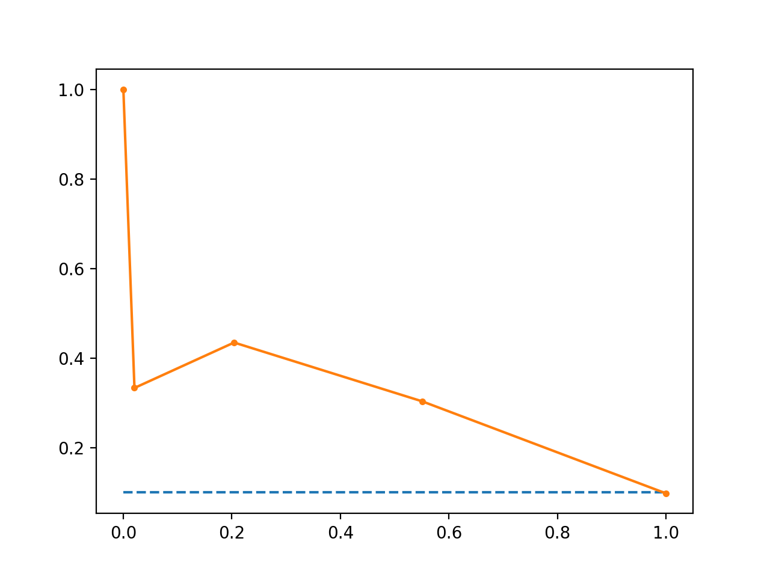

Line Plot of Precision-Recall Curve Imbalanced Dataset